
Lesson 10: Play It Again
GDevelop
VIDEO GAME CREATION
This week: when the round ends, the game actually stops - and pressing R brings it back to a genuinely fresh start.
Open your own [YourName]Game project from Lesson 9 - don't start a new one.
Tip: no new assets this week - this is a logic lesson, and it reuses your very first setup code from Lesson 5.

Setup
- Open your [YourName]Game project from Lesson 9.
- Add two new scene variables: GameActive (default value 1) and RestartRequested (default value 0).
- Add a new scene variable EnemyIndex (default value 0) if you don't already have one from Lesson 5.

Level 1 - Minimal (MVP)
When the round ends (win or lose), the game freezes - score and lives stop changing, and further enemy hits/escapes do nothing. Pressing R resets everything and starts a new round.
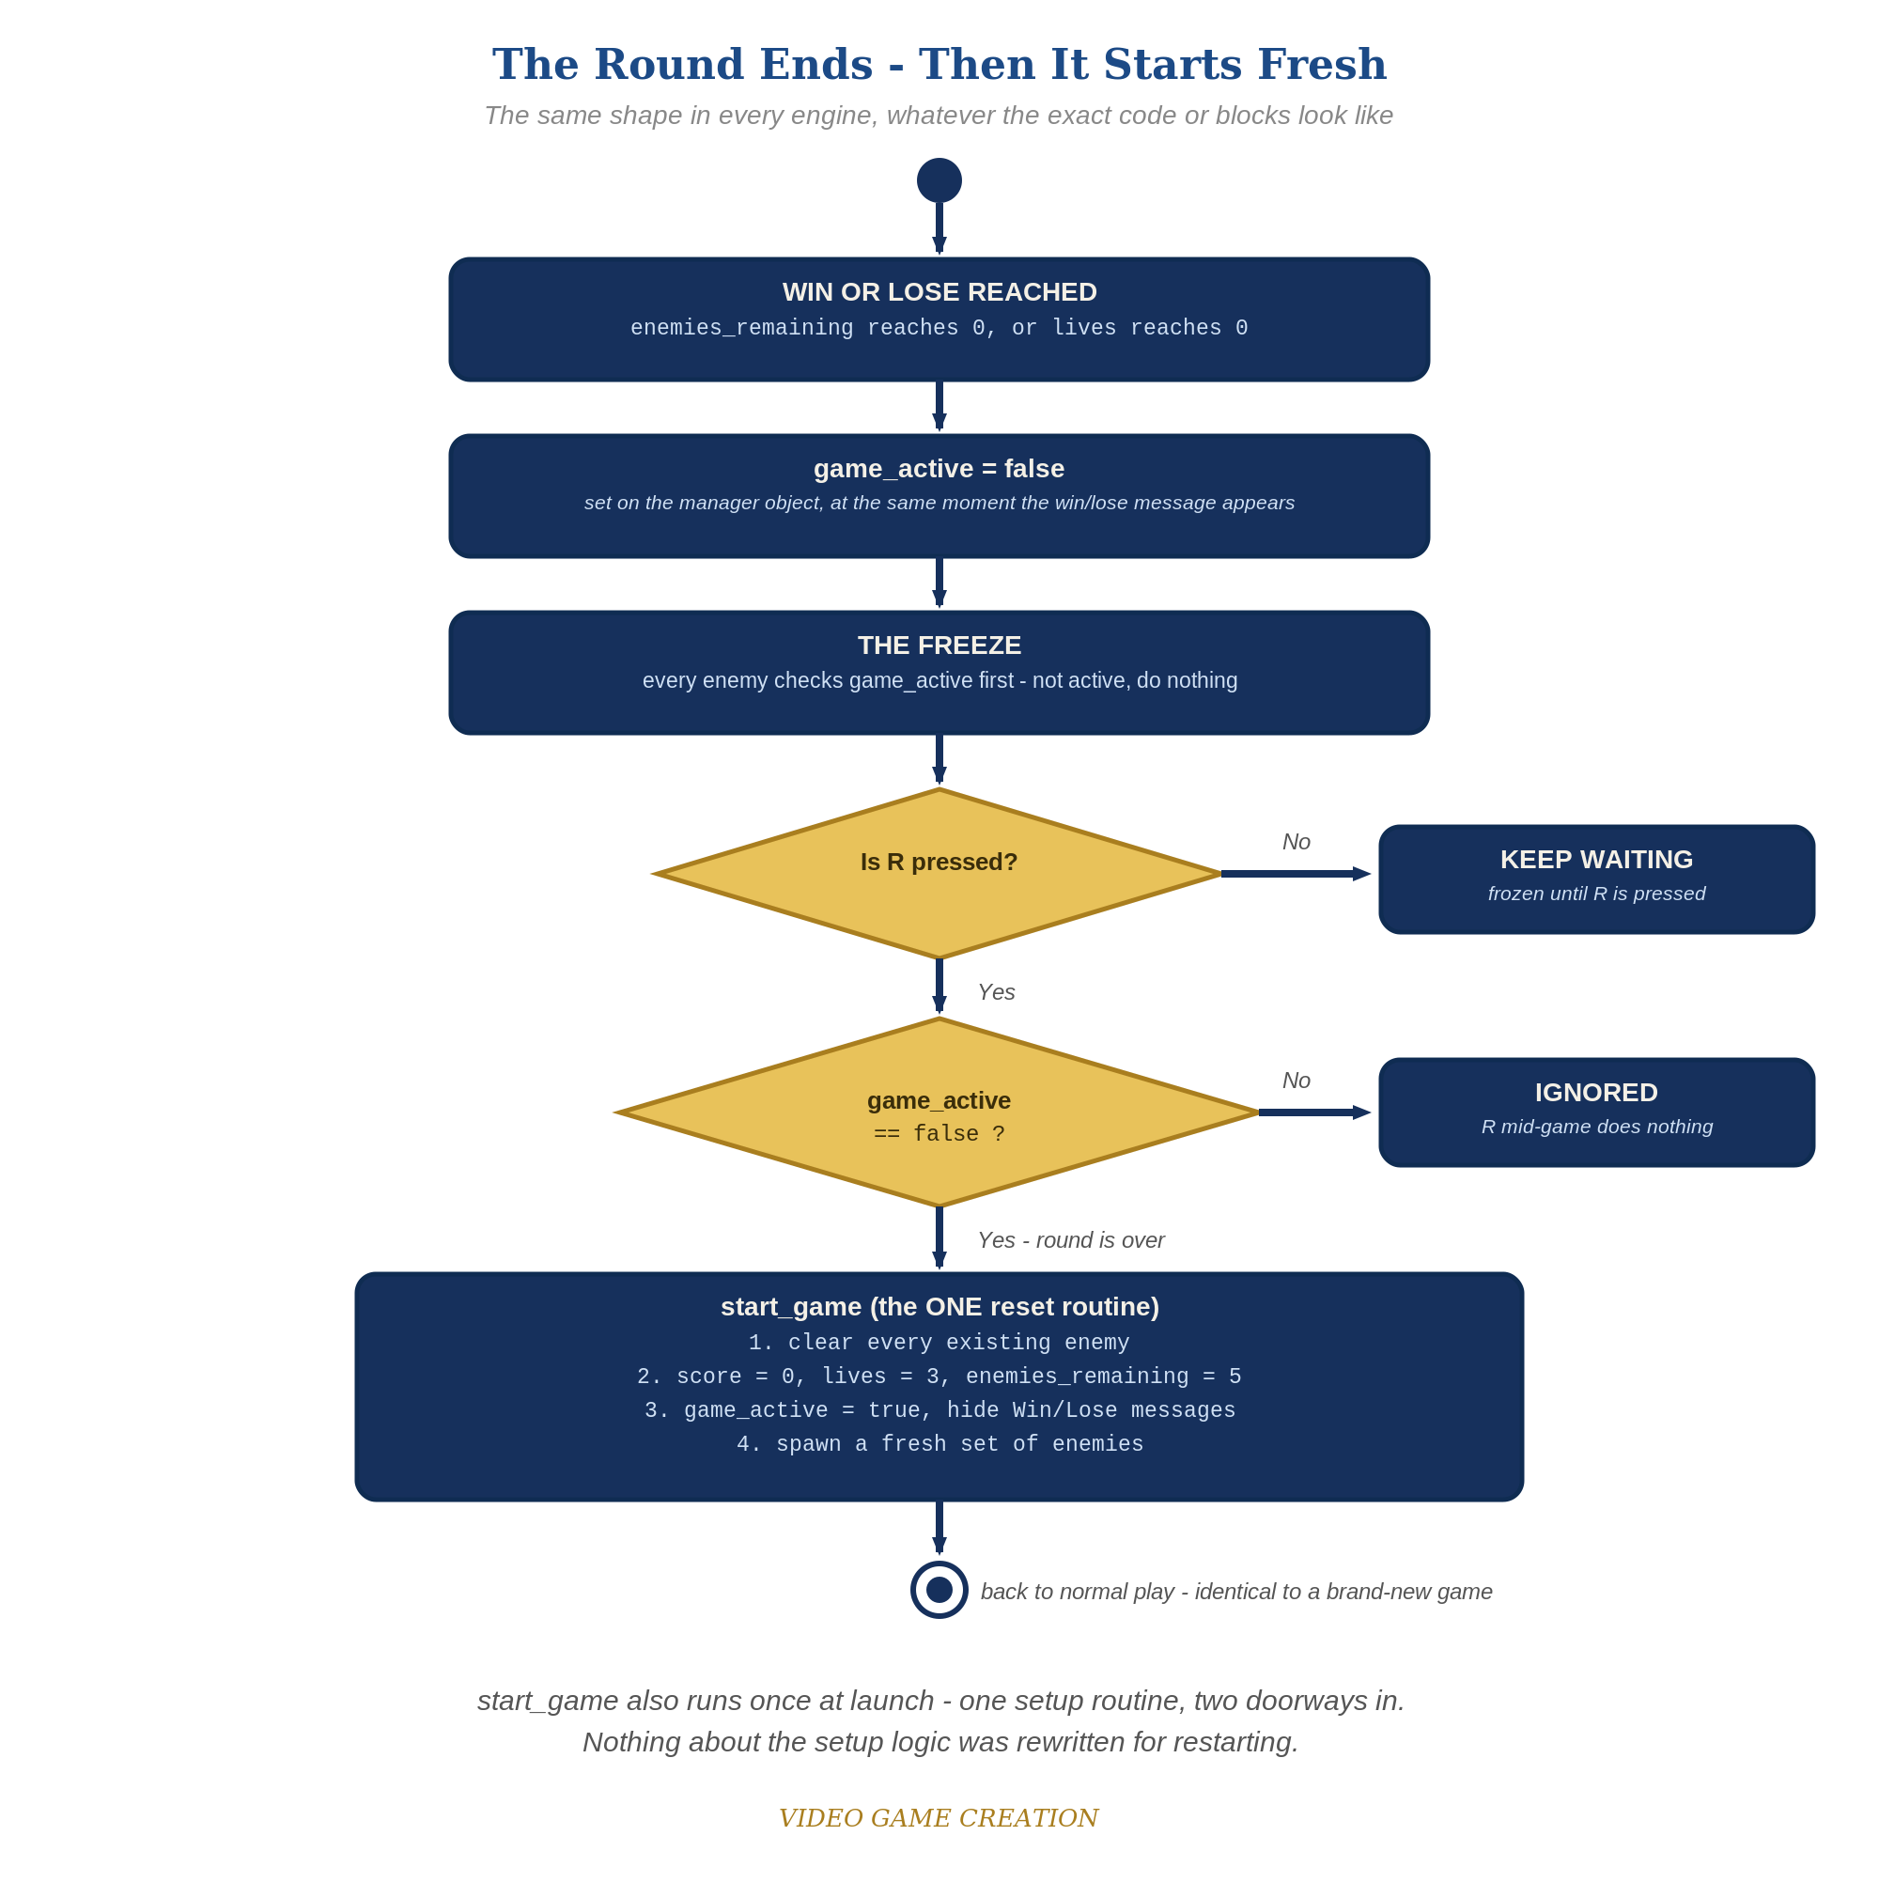
When the round ends, everything freezes - and R, pressed only while the round is over, runs the one reset routine. The same shape in every engine.
- Find your existing spawn event from Lesson 5 (it creates the Enemy objects at the start of the scene) and your existing event that sets the starting Score, Lives, and EnemiesRemaining. Move all of them into one labeled event group called "Setup".
- Change the Setup group's condition to an "Or" condition: [At the beginning of the scene] OR [RestartRequested = 1] (code below) - this makes the exact same setup logic run both the first time AND every restart.
- Inside the Setup group, add actions to delete all existing Enemy instances, reset Score, Lives, EnemiesRemaining, EnemyIndex, and GameActive to their starting values, set RestartRequested back to 0, hide WinText and LoseText, and then run your existing spawn actions (code below).
- On your enemy movement event, add GameActive = 1 as an additional condition - this freezes movement once the round ends.
- On the Combat group's win-check and the escape event's lose-check, when EnemiesRemaining or Lives reaches zero, also set GameActive to 0, and change the WinText/LoseText content to include the restart hint.
- Add a new event: Condition "Key R is pressed" AND "GameActive = 0" -> Action "RestartRequested = 1".
- Click Preview, play to a win or loss, confirm movement freezes, then press R and confirm everything resets and play resumes.
Highlighted lines are new this week; everything else is code you already have.
(Setup event group)
Condition: Or [At the beginning of the scene] [RestartRequested = 1]
Action: For each Enemy -> Delete Enemy
Action: Score = 0
Action: Lives = 3
Action: EnemiesRemaining = 5
Action: EnemyIndex = 0
Action: GameActive = 1
Action: RestartRequested = 0
Action: Hide WinText
Action: Hide LoseText
Action: Repeat 5 times -> Create object Enemy at (40 + EnemyIndex * 80, 40)
Action: EnemyIndex = EnemyIndex + 1 (inside the repeat)
(Enemy movement event, revised)
Condition: GameActive = 1
Action: Enemy.Y = Enemy.Y() + 30 * TimeDelta()
(Combat group - win check, revised)
Condition: EnemiesRemaining <= 0
Action: GameActive = 0
Action: Change text of WinText: "You Win! Press R to Restart"
Action: Show WinText
(Escape group - lose check, revised)
Condition: Lives <= 0
Action: GameActive = 0
Action: Change text of LoseText: "Game Over - Press R to Restart"
Action: Show LoseText
(new event)
Condition: Key R is pressed
Condition: GameActive = 0
Action: RestartRequested = 1

Level 2 - Complete (Alpha/Beta)
A restart is a genuinely clean slate - no leftover enemies, no stale score/lives, and it works correctly no matter how many times in a row you play.
- Play to a win, confirm movement freezes, then press R and confirm Score/Lives/EnemiesRemaining are exactly back to 0/3/5 with no leftover Enemy instances.
- Repeat for a loss - same clean reset.
- Press R while the game is still active and confirm NOTHING happens - the GameActive = 0 condition on the restart event is what prevents an accidental reset.

Level 3 - Refined (Ready to Publish) - pick any that interest you
- Visual: add a fade-in/out effect using an opacity Tween on WinText/LoseText instead of an instant show/hide.
- Structure: notice the Setup group is now the single place that sets up a fresh game - reached both "At the beginning of the scene" and on every restart via the Or condition. No setup logic is duplicated anywhere in your event sheet.

If Something's Wrong
- Restart does nothing when you press R: confirm the new event's two conditions are both present (Key R pressed AND GameActive = 0) - forgetting the GameActive check means R does nothing at all, since RestartRequested would never lead anywhere without the Setup group's Or condition also being satisfied.
- Restart leaves old enemies on screen: confirm "For Each Enemy -> Delete Enemy" runs BEFORE the Repeat-5-times spawn action inside the Setup group, not after.
- Enemies still move after game-over: confirm GameActive = 1 was actually added as a condition on the movement event, not just referenced elsewhere.

Want More?
Student Resource List > GDevelop section, or gdevelop.io/tutorials

